A REPORT ON

CONSTRUCTION OF BRIDGE RECTIFIER



A report submitted for the partial fulfillment of the requirements for the secondary level education of national examinations board

| Submitted By:  Suresh Acharya  12 ‘B’  Roll no: 37  Batch: 2078 | Submitted to:  Mr. sujan Lamsal  Mr. Manuraj Baral  Department of Science(Physics)  Gandaki Boarding School  Lamachour, Pokhara |
| --- | --- |

APPROVAL

Group-B (XII , Section-B) has carried out the study entitled “Construction of Bridge Rectifier.”

We approved the report for the partial fulfillment of the requirement for the secondary level education.

Mr. Sujan Lamsal

Mr. Manuraj Baral

Department OfScience(Physics)

Gandaki Boarding School

Lamachaur, Pokhara 16

Date: March, 2022

I

ACKNOWLEDGEMENT

We are extremely grateful to Mr. Sujan Lamsal, Physics Teacher and Mr. Manuraj Baral, Physics teacher, for their valuable guidance and the suggestion in preparing this report and the corrections and rearrangements he made.We would like to express our special thanks to everyone for their valuable support.

II

ABSTRACT

Rectifiers are the devices used to convert Alternating current(AC) to Direct Current(DC). Diodes are used for this process due to their forward and reverse bias characteristics. A diode will let current pass forward biased and block it when reversed biased. Based on this characteriscts, a rectifier is designed. In this report we’re going to look into the ‘Bridge Rectifier’, which is a type of rectifier. The basic principle and design of the device are discussed in the report. A self made model was submitted along with the report which can be compared with the construction of this rectifier.

III

CONTENTS

Approval I

Acknowledgement II

Abstract III

Introduction 1

Construction 1

Working 2

Characteristics Of Bridge Rectifier 5

Advantages 6

Disadvantages 6

Introduction

Bridge Rectifiers are circuits that convert alternating current (AC) into direct current (DC) using diodes arranged in the bridge circuit configuration. Bridge rectifiers typically comprise four or more diodes. The output wave generated is of the same polarity irrespective of the polarity at the input.

Bridge rectifiers are in the same class of electronics as half-wave rectifiers and full-wave rectifiers to rectify both half-cycles of a sine wave.

The bridge rectifier uses four diodes, connected together in a “bridge” configuration. The secondary winding of the transformer is connected on one side of the diode bridge network and the load on the other side.

Construction

The construction of a bridge rectifier is shown in the figure below. The bridge rectifier circuit is made of four diodes D1, D2, D3, D4, and a load resistor RL. The four diodes are connected in a closed-loop configuration to efficiently convert the alternating current (AC) into Direct Current(DC). The main advantage of this configuration is the absence of the expensive center-tapped transformer. Therefore, the size and cost are reduced.

1

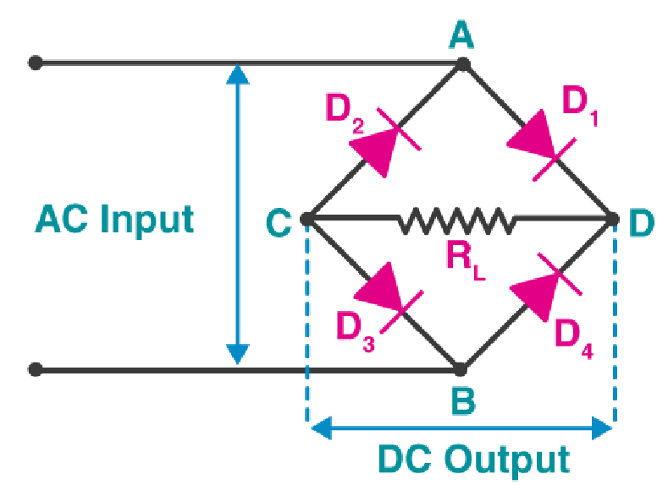

The input signal is applied across terminals A and B and the output DC signal is obtained across the load resistor RL connected between terminals C and D. The four diodes are arranged in such a way that only two diodes conduct electricity during each half cycle. D1 and D3 are pairs that conduct electric current during the positive half cycle. Likewise, diodes D2 and D4 conduct electric current during a negative half cycle.

Working

When an AC signal is applied across the bridge rectifier, during the positive half cycle, terminal A becomes positive while terminal B becomes negative. This results in diodes D1 and D3 to become forward biased while D2 and D4 become reverse biased. The current flow during the positive half-cycle is shown in the figure below:

2

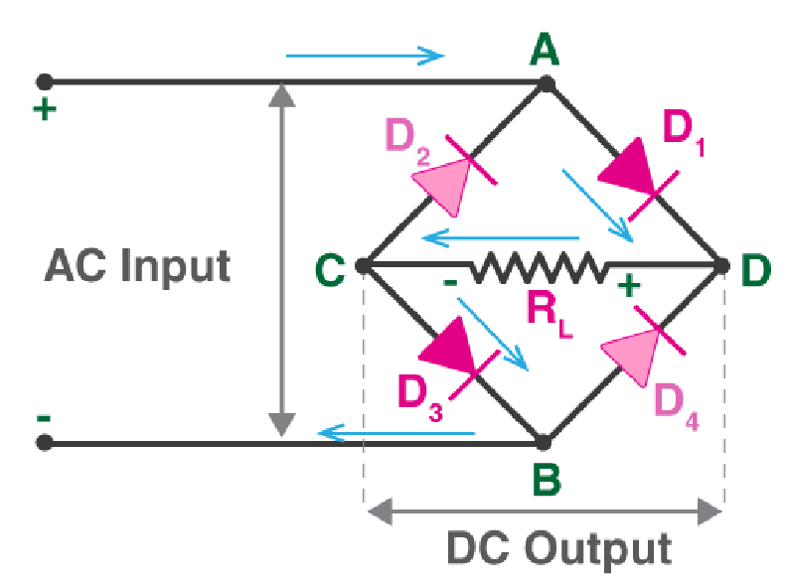

During the negative half-cycle, terminal B becomes positive while terminal A becomes negative. This causes diodes D2 and D4 to become forward biased and diodes D1 and D3 to be reverse biased. The current flow during the negative half cycle is shown in the figure below:

3

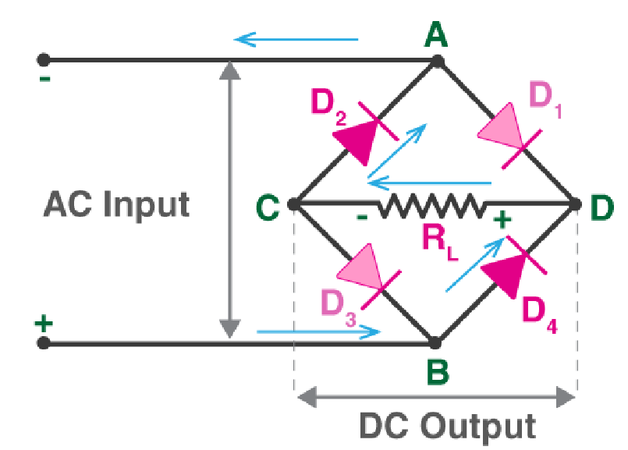

From the figures given above, we notice that the current flow across load resistor RL is the same during the positive half cycle and the negative half cycles. The output DC signal polarity may be either completely positive or negative. In our case, it is completely positive. If the direction of diodes is reversed then we get a complete negative DC voltage.

Thus, a bridge rectifier allows electric current during both positive and negative half cycles of the input AC signal.

The output waveforms of the bridge rectifier are shown in the below figure.

4

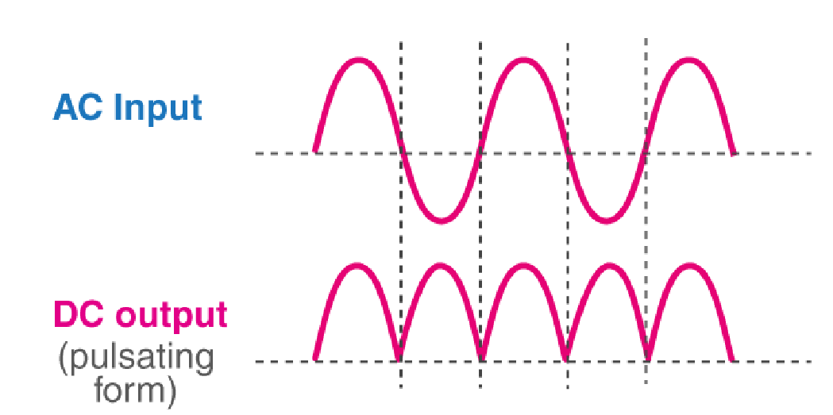

Characteristics of Bridge Rectifier

Ripple Factor

The smoothness of the output DC signal is measured by a factor known as the ripple factor. The output DC signal with fewer ripples is considered a smooth DC signal while the output with high ripples is considered a high pulsating DC signal.

Mathematically, the ripple factor is defined as the ratio of ripple voltage to the pure DC voltage. For bridge rectifiers, the ripple factor is 0.48.

Peak Inverse Voltage

The maximum voltage that a diode can withstand in the reverse bias condition is known as a peak inverse voltage. During the positive half cycle, the diodes D1 and D3 are in the conducting state while D2 and D4 are in the non-conducting state. Similarly, during the negative half cycle, diodes D2 and D4 are in the conducting state, and diodes D1 and D3 are in the non-conducting state.

Efficiency

The rectifier efficiency determines how efficiently the rectifier converts Alternating Current(AC) into Direct Current (DC).

5

Rectifier efficiency is defined as the ratio of the DC output power to the AC input power. The maximum efficiency of a bridge rectifier is 81.2%.

Advantages

* The efficiency of the bridge rectifier is higher than the efficiency of a half-wave rectifier. However, the rectifier efficiency of the bridge rectifier and the center-tapped full-wave rectifier is the same.
* The DC output signal of the bridge rectifier is smoother than the output DC signal of a half-wave rectifier.
* In a half-wave rectifier, only half of the input AC signal is used and the other half is blocked. Half of the input signal is wasted in a half-wave rectifier. However, in a bridge rectifier, the electric current is allowed during both positive and negative half cycles of the input AC signal. Hence, the output DC signal is almost equal to the input AC signal.

Disadvantages

* The circuit of a bridge rectifier is complex when compared to a half-wave rectifier and center-tapped full-wave rectifier. Bridge rectifiers use 4 diodes while half-wave rectifiers and center tapped full wave rectifiers use only two diodes.
* When more diodes are used more power loss occurs. In a center-tapped full-wave rectifier, only one diode conducts during each half cycle. But in a bridge rectifier, two diodes connected in series conduct during each half cycle. Hence, the voltage drop is higher in a bridge rectifier.

6